Appendix

Annual Review Self-Evaluation
Department of Philosophy

Name: Colin Mathers
Year: 2018

Use this template to document your past year’s activities. Attach a CV, teaching evaluations, course syllabi, and a proposed Plan of Work for the coming year, and submit the package electronically for presentation at the annual review meeting.

List courses taught, enrollment, and rating for “effective teacher” and grade distribution.

Course Title | Term | Enroll-ment | “Effective Teacher”  Rating | A | A- | B+ | B | B- | C+ | C | C- | D | F | I | W
Issues (05) | Sp | 37 | 4.13 | 6 | 7 | 4 | 3 | 4 | 0 | 6 | 3 | 2 | 0 | 0 | 2
Issues (03) | Sp | 38 | 4.14 | 4 | 5 | 4 | 7 | 2 | 5 | 5 | 1 | 3 | 1 | 0 | 1
Issues (02) | Sp | 40 | 3.79 | 11 | 2 | 4 | 4 | 3 | 3 | 1 | 1 | 4 | 1 | 0 | 6
Founds. | Sp | 32 | 3.95 | 6 | 2 | 3 | 4 | 1 | 4 | 5 | 1 | 2 | 0 | 0 | 4
Issues (05) | Fa | 37 | 4.53 | 13 | 3 | 2 | 4 | 2 | 2 | 0 | 3 | 6 | 2 | 0 | 0
Issues (06) | Fa | 40 | 3.67 | 14 | 4 | 4 | 5 | 7 | 2 | 0 | 0 | 2 | 0 | 0 | 2
Issues (07) | Fa | 37 | 4.27 | 8 | 2 | 5 | 6 | 5 | 3 | 1 | 3 | 2 | 1 | 0 | 1
Issues (08) | Fa | 31 | 4.2 | 9 | 3 | 7 | 2 | 5 | 2 | 1 | 0 | 0 | 1 | 0 | 1

List up to ten student comments from student evaluations which best represent assessment of your teaching.

Student 1: Professor Colin Mathers is by far the best professor I've had so far at RIT. He genuinely cares about the students, listening intently to their feedback (such as the time a student wasn't happy with all of the white depicted images of Jesus resulting in a meeting and purchase of more images), makes material interesting and fun to talk about, and keeps things very relaxed and humorous, yet engaging. I did not think I would have much of an interest in philosophy, yet, Professor Mathers guaranteed my interest in it.

Student 2: Very good policies and attempts to keep students engaged. Good stories to relate to the lesson. Very fair homework load. Just a generally pleasing professor, obviously engaged in any of the topics at hand even though sometimes they got dry. Tries hard to be the professor that you will remember in 10 years.

Student 3: The instructor encouraged students to share their answers and called on the shy ones so that they could have a turn too. Playing the original position card game then talking about it really enhanced my understanding of Rawls. Giving time for students to talk about questions about the reading and other related topics to a lesson and rewarding double points is extremely helpful and smart. The one minute phone break is a smart idea and is useful most of the time.

Student 4: Colin's class was structured extremely well and I feel like that was really conducive to establishing a good learning environment. The workbook problem structure for the class really made topics clear and easy to follow. Tests were easy to study for if the correct notes were taken in class and enough time was given to studying.

Student 5: Colin Mathers is a genuine professor. He is kind and makes everyone feel welcomed. Even when you get an answer wrong, he still makes you feel like you got some part of it right while also understanding that there is a better answer. He tells stories that relate to the material as well as life lessons that keep the class engaged and positive towards learning.

Student 6: Organization and smooth transitions into different topics are the strong suits of this instructor. Everything is already pre-planned so that if you want or need to get ahead, you can. The instructor provides variations of questions and pitfalls to concepts with in depth explanations that are clear. Another very helpful tool the instructor used was pictures to help visualize what the answer is supposed to be, or supposed to look like. The very short trivia questions at the start of class were a very helpful segment to sort of relax and step out of the student mindset and participate in something that isn't work and that's also interesting.

Student 7: Unlike my other classes that were driven by the professor at all times, this class was much more student driven and the questions we were discussing were shaped by our feedback and thoughts on the subjects.

Student 8: Professor is very passionate about what he is teaching and delivers material in an engaging manner. Often tells us stories about his past teachers and different lessons he learned from them. The tests are perhaps the most fair among any tests I have taken here at RIT. He makes it very clear what is expected from us and what to study. I genuinely enjoyed having him as a professor.

Student 9: Very helpful feedback on graded material. The way that in class discussions were run especially with the optional sharing really helped me understand the material better.

Student 10: The whole class was less of a lecture and more of a guided discussion. Discussion was mandatory as you could be randomly called on, but it was good to be forced to really think for yourself.

Other relevant information including course development and modification, ongoing pedagogical practices, pedagogical experimentation, and pilot projects.

- New Mind Maps

I added the following 5 mind maps to MyCourses for Moral Issues: Overview, Theory Overview, Moral Pluralism, Utilitarianism, and Distributive Justice. The images are largely drawn from my PowerPoint slides and videos and, thus, help students process the lessons.

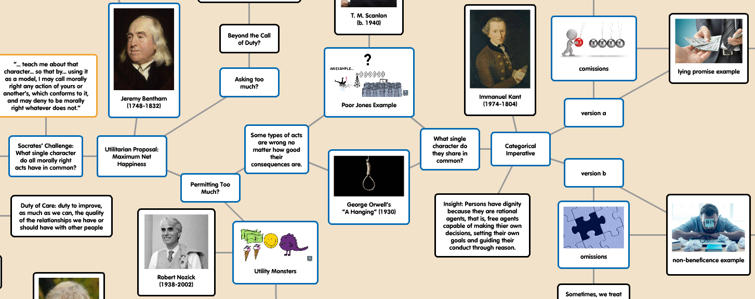

- Substantial Overhaul of Existing PowerPoint Slides

I substantially overhauled the PowerPoint images that complement problem-set review sessions. Teaching and Learning Services supplied funds for buying images, and I discovered that paid images were not only more aesthetically pleasing, but also were very helpful in making images more inclusive. (Too many free images feature only white people.)

- New PowerPoint Slideshows

I also turned my attention from image-based slides that complement problem-set review sessions to image-based slides for lessons beyond the problem sets. These image-heavy lessons still call for frequent problem-solving, but not for producing solutions that may be scored. New slideshows were produced for Physician-Assisted Suicide, Utilitarianism, Distributive Justice, and the Categorical Imperative.

- New Meta-Cognition Assignment

Taking an idea from Kristen Condry’s Teachers-on-Teaching presentation, I offered any student who scored below a B- on their first exam the opportunity to earn back a few points by writing a reflection piece around the following 3 prompts: (1) What could the instructor have done differently to help me prepare better for the exam? (2) What could I have done differently to prepare better for the exam? (3) How can I apply what I wrote for the second prompt to other classes at RIT?

The writings were very informative for students and for me. I advised students about preparing for the second exam by showing slides featuring anonymous quotes from the writings and, of course, complementary images.

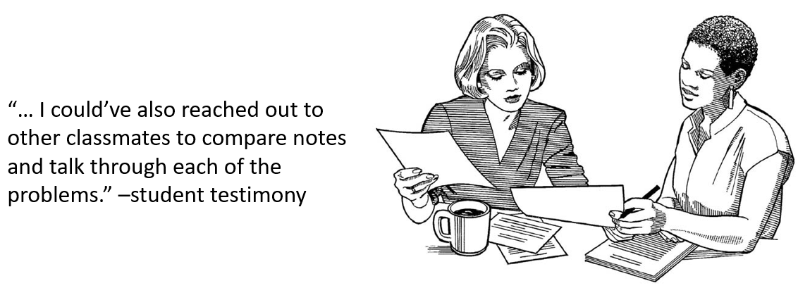

- Re-learning Symbolic Logic

To help fulfill the needs of the department, I volunteered to teach Symbolic Logic in 2019. Since I hadn’t worked through exercises in symbolic logic for over 20 years, I re-learned how to do them.

Service to the Department, College, University or Profession

- Teaching and Learning Services Collaborations

TLS solicited my participation on a GOLD faculty panel. I shared my experiences and advice with instructors enrolled in the Guided Online Learning Development workshop series.

TLS also solicited my participation in aiding individuals transitioning from industry to teaching. In pursuit of Master’s degrees in Individualized Studies, students worked with Rebecca Johnson to earn credits in Instructional Design. In that context, my classroom was observed. I also prepared materials for pre-observational and post-observational meetings.

- Co-director of RIT’s 9th Annual Undergraduate Philosophy Conference:

Tasks handled include collecting, organizing and distributing papers to faculty and student readers; reading all submissions; leading a meeting in which final decisions were made with respect to accepted presenters and alternates; making catering arrangements with Crossroads for morning food and beverage and Wegmans for lunch; making dinner arrangements at Lovin’ Cup; and writing a post-event summary to aid in the release of grant money from Student Affairs.

- Director of RIT’s 10th Annual Undergraduate Philosophy Conference:

Tasks handled include: reserving event space, writing grant proposal for additional funding from the Office of Student Affairs, requesting and organizing keynote speaker recommendations from the department, designing and distributing call for papers, communicating with several candidates for keynote speaker.

- Co-organizer for Department of Philosophy Spring Social:

Tasks handled include: reserving event space, assisting with coordinating theme (drawing philosophers and philosophical ideas), arranging for the provision of beverages and cups.

- Gen Ed Assessment

My Introduction to Moral Issues was selected for the Fall 2018 assessment of RIT’s General Education Social Perspective Student Learning Outcome: Analyze similarities and differences in human social experiences and evaluate the consequences. Not only did I collect and submit data as requested, but I also worked with Leah Bradley to fine tune my assignment for inclusion in RIT’s General Education Assignment Library.

- Teaching Circle Facilitator:

Tasks include: drafting and submitting a teaching circle proposal, working with Michael Starenko (TLS) to refine circle description and recruit 6 other faculty, presenting and/or leading discussion for our 4 Spring meetings, and creating 3 PowerPoint slideshows: one on image selection, one on the results of a survey on imagery conducted in one of my classrooms, and one combining the work of all circle members shown at a luncheon with other teaching circles.

Description included below:

Using Imagery to Help Stimulate Critical Thinking
Colin Mathers (Philosophy)
Recent research shows that supplementing audio/textual stimuli with imagery in the classroom can be beneficial to students. This teaching circle explores how student-centered approaches aimed at critical thinking can be enhanced by means of imagery. If a picture is worth a thousand words, then we can expect that supplementing a question or a problem with one or more images can help create intellectual excitement where it is missing and increase it where it is not. Areas for exploration include current research on imagery, finding and selecting images, developing imagery-prompted learning activities, and flipping the script by having students propose images of their own.
- Community Representative on Rochester General Hospital Ethics Committee: New York State law requires the presence of a Community Representative during ethics consults. During a particularly busy year for the committee, I attended, on very short notice, and fully participated in several ethics consults.

