Appendix

Annual Review Self-Evaluation
Department of Philosophy

Name: Colin Mathers
Year: 2019

List courses taught, enrollment, and rating for “effective teacher” and grade distribution.

Course Title | Term | Enroll-ment | “Effective Teacher”  Rating | A | A- | B+ | B | B- | C+ | C | C- | D | F | I | W
Intro to Moral Issues (01) | Spr | 37 | 4.5 | 12 | 3 | 4 | 4 | 2 | 1 | 2 | 2 | 4 | 4 | 0 | 1
Intro to Moral Issues (02) | Spr | 38 | 4.53 | 10 | 5 | 0 | 8 | 1 | 3 | 2 | 0 | 3 | 3 | 1 | 3
Intro to Moral Issues (03) | Spr | 40 | 4.37 | 11 | 5 | 7 | 4 | 1 | 2 | 6 | 0 | 1 | 2 | 0 | 1
Symbolic Logic | Spr | 32 | 4.02 | 12 | 2 | 3 | 2 | 2 | 1 | 0 | 2 | 1 | 0 | 0 | 7
Intro to Moral Issues (01) | Fall | 40 | 4.14 | 12 | 6 | 2 | 5 | 5 | 3 | 2 | 1 | 3 | 0 | 0 | 1
Intro to Moral Issues (02) | Fall | 40 | 4.39 | 16 | 5 | 4 | 5 | 4 | 0 | 2 | 1 | 1 | 2 | 0 | 0
Intro to Moral Issues (03) | Fall | 38 | 4.46 | 11 | 5 | 6 | 3 | 3 | 4 | 1 | 0 | 2 | 0 | 0 | 3
Foundations of Moral Philosophy | Fall | 31 | 4.24 | 11 | 2 | 4 | 5 | 0 | 0 | 1 | 0 | 2 | 1 | 0 | 5

List up to ten student comments from student evaluations which best represent assessment of your teaching.

Student 1: His use of myCourses is unparalleled. I have never seen myCourses used so well and effectively until I had him.

Student 2: Being in-class was a phenomenal experience. A great environment was created and it felt like a safe place to share opinions and have discussion. The videos were also a great resource as the readings were very difficult to interpret. I consistently learned more from the videos than the assigned readings.

Student 3: This was my favorite course this semester and possibly overall even though I have limited interest in the field as a whole.

Student 4: He put a lot of work into ensuring that everyone gets the most they can out of the class. He provides a lot of material to supplement and review the work done in class. He is good at explaining complicated topics in ways that are understandable.

Student 5: He is an excellent teacher. He lead class discussions very well and knew when to comment on what was being said or when to lead the class to focus on other material. I also really like his approach to moral issues homework and treating it almost like math problems. It really helped me understand the material by practicing regularly and doing it myself.

Student 6: The instructor was very good about leading class discussions and walking through different philosophical theories and the costs and benefits of those theories. He was also very open to new ideas and worked through student examples properly to show any issues with the examples. The instructor showed initiative in reacting towards mid-semester feedback from students to slightly alter course structure. Provided a plethora of outside resources from which to understand the material. The instructor was also very clear on grading policies.

Student 7: I really liked that this professor was very relatable to students. He took the time to learn all of our names and encouraged us to share stories about our lives. It made the class feel much more personal and definitely helped create a positive learning environment.

Student 8: I admit I already had an interest in this class before, but Mathers does an amazing job of teaching this class. He keeps a good energy, never is judgmental, and helps out wherever he can. The course's organization is also pristine!

Student 9: Dr. Mathers was incredibly clear and concise in his explanations of topics in class. And, as mentioned by other students, each unit built into the next very well. The in-depth discussions of each problem helped me really understand the material, as different students gave different examples, and I was able to pick the ones that helped me the most. The format of the slides was also very helpful, with many examples, including those from past students!

Student 10: Professor Mathers is THE MOST APPROACHABLE professor I had. Very nice. Does not judge the students in the least. Always replied to the emails. Very good policies. He puts a lot of work and thought into planning his course and it shows clearly.

Other relevant information including course development and modification, ongoing pedagogical practices, pedagogical experimentation, and pilot projects.

- An Image-Heavy Symbolic Logic Course

Many years ago, I had taught symbolic logic at the University of Rochester. I simply explained how to solve problems and supervised students in workshop sessions. For my Spring 2019 Symbolic Logic, I painstakingly assembled and incorporated well over one hundred images to help students master symbolizations, truth tables and derivations.

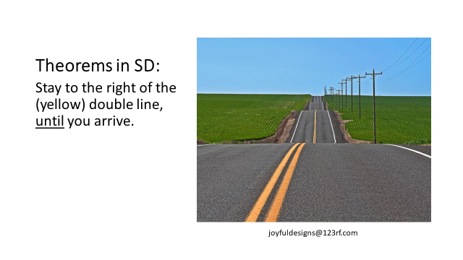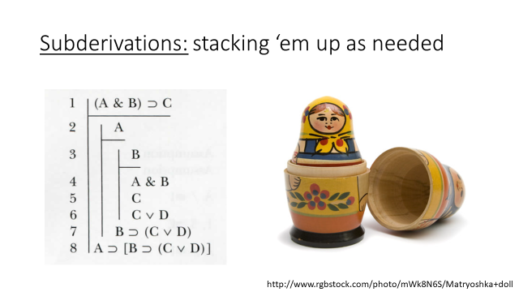

- Building Visual Design Principles into Slides

I put into practice some visual design basics that I picked up from a presentation by College of Art and Design professor, Hye-Jin Nae. For example, to avoid implying unwanted emphasis, Hye-Jin recommended that images on slides showing comparisons or contrasts should be of roughly equal size. (Below is a pair of before and after slides.) I made countless such tweaks to my slides over the summer.

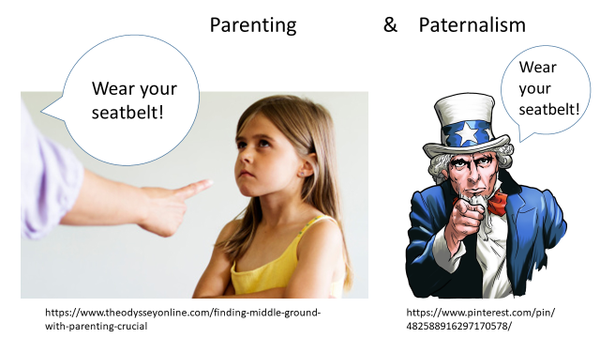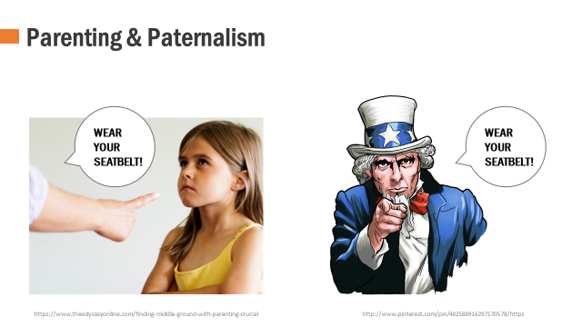

I also used these basics to create dozens of new slides designed to help my students stay in the know about (a) upcoming due dates, (b) resources available on myCourses, and (c) upcoming philosophy talks.

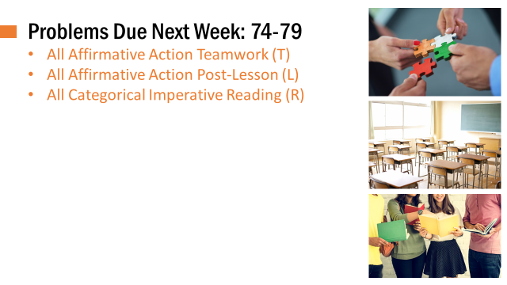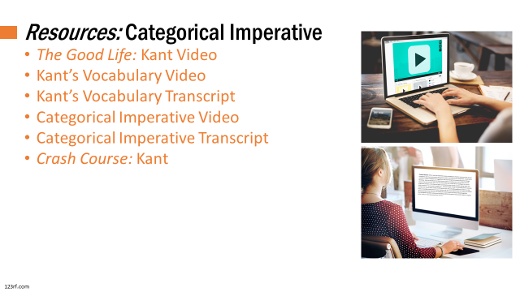

- Office of EEA Grant and Substantial Revisions to Moral Issues Workbook

From the Office of Educational Effectiveness Assessment, I received an Innovative Assignment Design Grant to follow up on ideas that emerged in a May workshop. The grant supported summer work that resulted in substantial revisions to my Moral Issues workbook. The most significant of these are (a) becoming more explicit about the goals of the assignment and (b) creating new writing prompts for student explorations beyond the classroom. When I set to the task of articulating goals, it occurred to me that I should prompt students to identify some goals of their own.

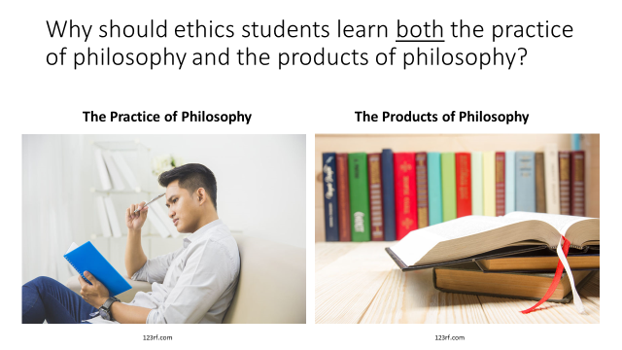

Here are three student responses:
“I hope, by studying the practices and products of philosophy, I am able to develop tools and critical thinking mechanisms that I will be able to use in many aspects of life. I would like the ability to form strong arguments, but also spot those with bad reasoning. I would like to be able to find the answers to my own ethical dilemmas and also comprehend alternate views.”

“I think the benefits of philosophy are numerous. First, I think it has a role in modern day politics and the formation of our own opinions. Second, I think philosophy extends to my personal discipline, computer science. As someone especially interested in machine learning and artificial intelligence, ethics will certainly play a large role in the development of intelligent systems and their interactions with humans.”

“I expect to achieve the best version of myself that I can be. By applying these practices and products of philosophy, I can make better decisions and become a better human being.”

- Pedagogical Workshops Participated In or Attended

- Teachers on Teaching: Carol Marchetti on Effective Student Teamwork
- Teachers on Teaching: Hye-Jin Nae on Visual Design Principles that Impact Learning
- Innovative Assignment Design Workshop (Office of Educational Effectiveness Assessment)
- Becoming an Inclusive-Minded Faculty Member (Division of Diversity and Inclusion)
- How to Use Interactive Lecturing as Pedagogy of Engagement
6. Elevating Deaf Inclusion in Your Classroom – Change One Thing

Service to the Department, College, University or Profession

- Director of RIT’s 10th Annual Undergraduate Philosophy Conference:

Tasks handled include receiving, reading and ranking all submissions; handling communications with keynote speaker; confirming catering orders; making dinner arrangements; and writing a post-event summary to aid in the release of grant money from Student Affairs.

- Director of RIT’s 11th Annual Undergraduate Philosophy Conference:

Tasks handled include serving on a committee to determine the nature of the 2020 conference; exploring funding possibilities; meeting with the philosophy club executive board to discuss finer details.

- Gen Ed Assessment

My Introduction to Moral Issues was selected for the Fall 2019 assessment of RIT’s General Education Social Perspective Student Learning Outcome: Identify contemporary ethical questions and relevant positions. Not only did I collect and submit data as requested, but I am working with Leah Bradley to facilitate use of my assignment as an exemplar in RIT’s General Education Assignment Library.

- Community Representative on Rochester General Hospital Ethics Committee:

New York State law requires the presence of a Community Representative during ethics consults. During another busy year for the committee, I attended, on very short notice, and fully participated in several ethics consults.

